SAMUEL JOHN

# F o o d a n d B e v e r a g e a s s o c i a t e

**PERSONAL BACKGROUND**

**WORK EXPERIENCE**

Enthusiastic and committed - offering 2 years of experience in the food and beverage division within the hospitality sector. My aim is to excel, provide and meet guests' expectations through competency and sheer creativity.

**ACCOMPLISHMENTS**

* The highest single up seller for the quarter from Jan 2020 to March 2020
* Helped curate a business proposal and presentation for the management - revamp of the restaurant concept.
* Best simulation programme presented in S.P.Jain school of management. August 2018 - Dec 2018

**LANGUAGES**

English - Full professional French - Limited working Hindi - Native

## Food and Beverage Associate

#### *Park Hyatt Abu Dhabi Hotel and Villas. | Jan 2019 - Feb 2020*

* Well practiced in the provision of competent and meticulous service in an all day dining, fine dining and an award winning Mediterranean restaurant - the beach house.
* Well versed in the sequence of service and meeting the SOP's, and procedures set by the hotel and restaurant. - Trained under HACCP guidelines and Hyatt protocol.
* Positioned as captain in place when the leaders were on their weekly leaves; undertaking it's full responsibility in whole including the leading of the team and delegating certain tasks for the day.
* In depth knowledge regarding food and beverage, mainly local menus
* Effectively used items in stock to decrease waste and profit loss
* Catered to high volume covers ranging from 80 to 200 in single operation.
* Effective knowledge in MICROS and its' system overall.

## Food and Beverage Intern

#### *Park Hyatt Abu Dhabi Hotel and Villas | August 2018 - Dec 2018*

* Well trained and knowledge acquired to cater to guests and meet their expectations
* Training on MICROS usage, inventory and shrinkage, package forecasting and reading of various reports.

**EDUCATION**

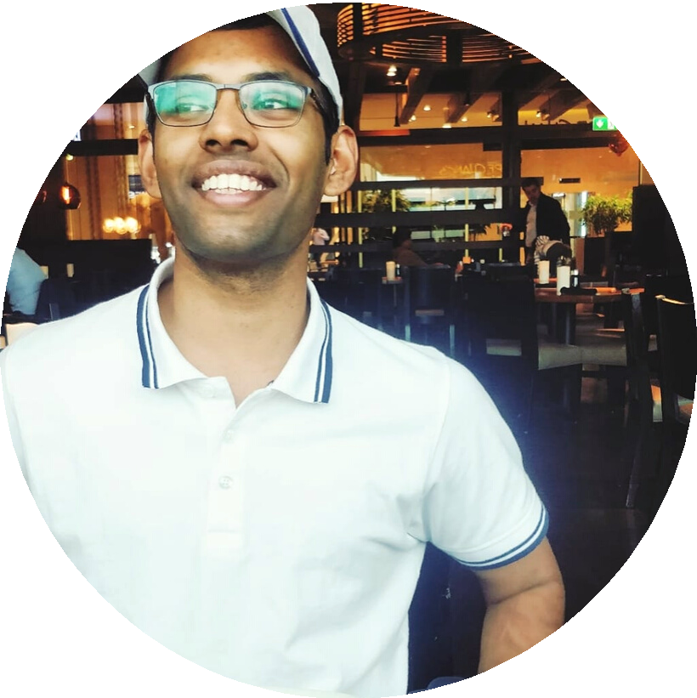

* Al Noor Training Centre for Children with Special Needs

**EXTRA-CURRICULAR ACTIVITES**

* Sharjah Electric Run - merchandise supplier
* Mercithon walk - walk for cancer
* Emirates Literature Festival

**GET IN TOUCH WITH ME**

Cell: +971544330051

Email: [samueljvarghese@gmail.com](mailto:samueljvarghese@gmail.com) Linkedin: Samuel John

Skype: samueljvarghese

## Ecole hoteliere at Lavasa

### *Bachelor of Arts in Hospitality Management*

* General secretary for the food and beverage group
* Class valedictorian
* Majored in Food and Beverage in whole

## Al Diyafah High School

### *Dubai, U.A.E*

* Completion of AS and A levels
* Completion of IGCSE studies